HOME PAGE

Step1:

Coding of website HTML

<!DOCTYPE html>

<html lang="en">

<head>

    <meta charset="UTF-8">

    <meta http-equiv="X-UA-Compatible" content="IE=edge">

    <meta name="viewport" content="width=device-width, initial-scale=1.0">

    <title>Portfolio</title>

    <link rel="stylesheet" href="style.css">

</head>

<body>

    <nav class="navbar">

        <ul>

        <li><a href="#home">Home</a><li></li>

        <li><a href="#portfolio">Portfolio</a><li></li>

        <li><a href="#pesonal statement">pesonal statement</a><li></li>

        <li><a href="#about">About me</a><li></li>

        <li><a href="#contact">Contact me</a><li></li> </ul>

    </nav>

    <section id="Home">

        <h1 class="Heading">HI,I AM</h1>

        <h1 class="Heading">NOMAN IJAZ</h1>

        <br><br>

    </section>

    <section id="portfolio">

        <h1 class="heading">portfolio</h1>

        <div class="gallery">

            <img src="C:\Users\Noman\Desktop\img.jpg" >

        </div>

    </section>

    <section id="Personal statement ">

        <h1 class="heading">Personal statement</h1>

        <div class ="columns">

            <div class="box">

                <h2> PERSONAL STATEMENT PAGE

                    <p></p>

                </h2>

            </div>

        </div>

    </section>

    <section id="about">

        <h1 class ="heading">About me</h1>

        <div class ="about">

            <img src="C:\Users\Noman\Pictures\4.jpg">

            <div class="name">

                <h2>I AM NOMAN IJAZ </h2>

                <p>My Name is NOMAN ijaz.I am from Sargodha .I did my matric from GOVT Central model high School and I did

                    my Intermediate from Punjab college and now I am in FAST NUCES AT CFD CAMPUS.I am a student of first smester.

                    </p>

            </div>

        </div>

    </section>

    <section id="Contact">

        <h1 class="heading">Contact</h1>

        <form action=""class="form">

            <input type="text" name="name" class="input" placeholder=" Plz Enter your Name ">

            <input type="email" name="email" class="input"

            placeholder="Enter your email">

            <textarea name="message" id="message" cols="70" rows=20

            placeholder="Enter your Message "></textarea>

            <input type ="submit" value="submit" id="submit">

        </form>

    </section>

</body>

</html>

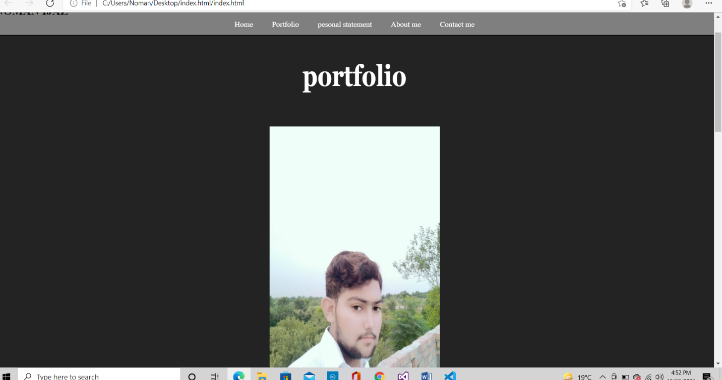

In this home page I used a section id .an ID is a unique element used in html for documentation

Also I used div class for division of content and navbar for navigiation of links

Coding of a website for CSS :

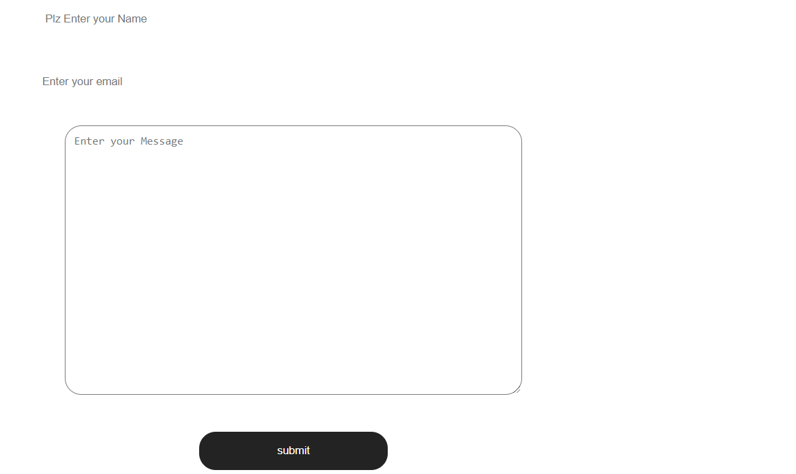

Coding of CSS

\*{

    margin:0;

    padding:0;

}

html{

    scroll-behavior: smooth;

}

/\*navbar\*/

.navbar{

    display:flex;

    justify-content:center;

    height:50px;

    align-items:center;

    position:sticky;

    top:0;

}

.navbar::before{

    content:"";

    position:absolute;

    background-color: rgba(0,0,0,0.5);

    height:100%;

    width:100%;

    z-index:-1;

}

.navbar ul{

    display:flex;

    list-style:none;

}

.navbar ul li a{

    padding: 5px 20px;

    text-decoration:none;

    color:white;

}

.navbar ul li a:hover{

    border-bottom:2px solid yellow;

}

/\*Home Section \*/

#home{

    display:flex;

    flex-direction:column;

    height:650px;

    justify-content:center;

    align-items:center;

    background-color: rgba(0,0,0,0.5);

    color:white;

}

#home::before{

    content:"";

    position:absolute;

    top:0;

    left:0;

     background:url('bg.jpg') no-repeat center center /cover;

     height:700px;

     width:100%;

     z-index:-1;

     opacity:.8;

}

.heading{

    color: white;

    font-size:3rem;

    font-family:Georgia, 'Times New Roman',Times,serif;

    text-align:center;

    transform:scale(1,1.3);

}

/\*portfolio Section\*/

#portfolio{

    display:flex;

    flex-direction:column;

    background-color: #000000dc;

}

#portfolio h1{

    margin:60px;

}

.gallery{

    display:flex;

    justify-content:space-around;

    flex-wrap:wrap;

}

.gallery img{

    width:360px;

    height:640px;

    padding:10px;

    margin:10px;

}

.gallery img :hover{

    background-color: white;

    cursor:pointer;

}

/\*Education Section \*/

#education {

    display:flex;

    flex-direction:column;

    background-color: #000000dc;

}

education h1{

    margin:60px;

}

.columns{

    display:grid;

    grid-template-columns:auto auto;

    padding-left:50px;

}

.box{

    height:200px;

    width:500px;

    border-radius: 20px;

    margin: 10px;

    padding:20px;

}

.box h2{

    color:yellowgreen;

    margin-bottom:40px;

}

.box p{

    color:white;

    font-size:1.1rem;

}

/\*About Section \*/

#about{

    display: flex;

    flex-direction: column;

    height:600px;

}

#about h1{

    color:palegreen;

    margin:55px;

}

.about{

    display:flex;

}

.about img{

    width:500px;

    height: 400px;

    padding:0px 30px;

}

.name{

    padding:10px;

}

.name h2{

    font-size:2rem;

}

.name p{

    font-size:1.2;

}

/\*Contact Section\*/

#contact{

    display:flex;

    flex-direction: column;

    background-color: #000000dc;

}

#contact h1{

    margin:50px;

}

.form{

    display: flex;

    flex-direction: column;

    align-items: center;

    justify-content: center;

}

.input{

    padding:15px 20px;

    margin: 15px;

    width:40%;

    border:none;

    outline: none;

    border-radius: 25px;

}

#message{

    margin: 15px;

    padding:10px;

    border-radius: 20px;

}

#submit{

    padding:15px 20px;

    margin: 30px;

    width:15%;

    border-radius: 20px;

    background-color: #000000dc;

    color: white;

    border:none;

    outline:none;

}

#submit:hover{

background-color:greenyellow;

cursor: pointer;

}